EXPERIMENT 4
RELATIONAL MODEL FOR SAILOR BOAT DATABASE

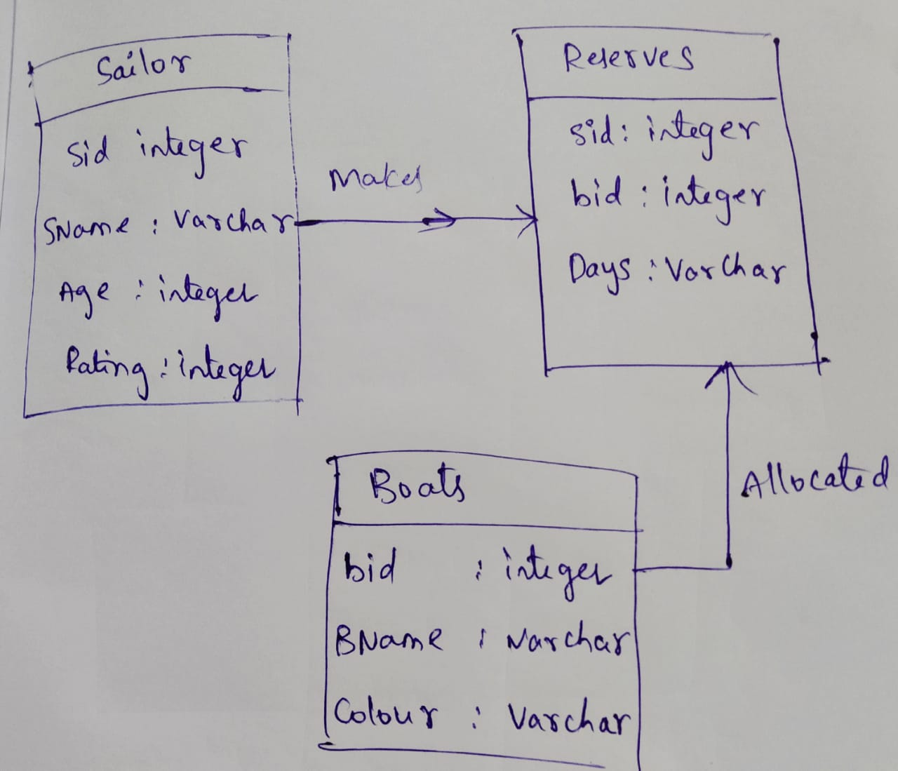
Aim: Draw a relational model for sailors database.

